Journey Through The Bible

**Josiah**

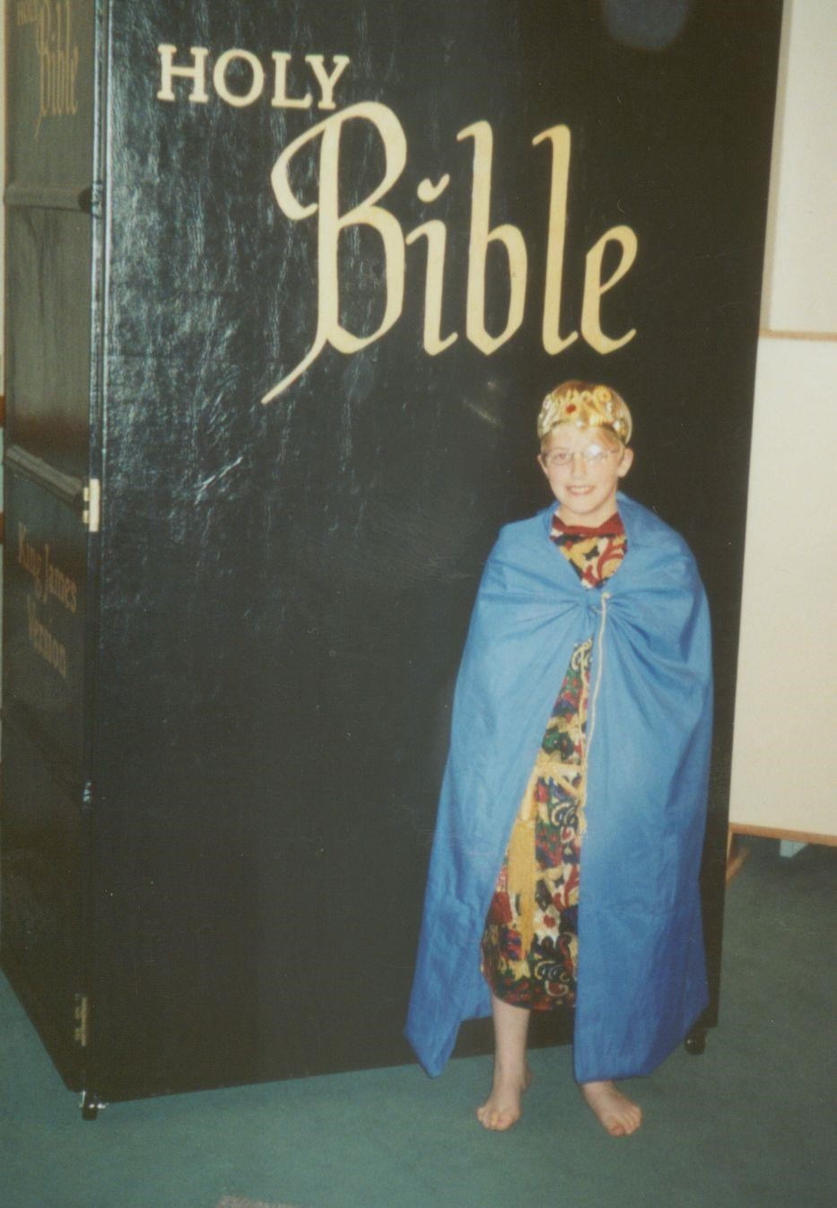

2 Kings 22:1-20

My name is Josiah and I am the king of Judah. I was crowned king when I was eight years old. I try to do what is right in the sight of the Lord.

It makes me sad to say that my father; King Amon, did what was evil in the sight of the Lord. He worshipped idols and did not humble himself before God. When he was killed by his servants in his own house, the people of the land made me king.

I walk in the ways of my ancestor, David; I do not turn aside to the right or to the left.

When I had reigned eight years as king, I began to seek the God of my ancestor, David, and in the twelfth year, I began to rid Judah and Jerusalem of the high places of idol worship and the images of false gods. I made dust of them and scattered it over the graves of those who had sacrificed to them. I burned the bones of the evil priests on their altars. I broke down the altars and images of the false gods in the towns of Manasseh, Ephraim, Simeon, and as far as Naphtal I ground the images into powder and destroyed all the incense altars throughout the land of Israel. I then returned to Jerusalem. I will try serve my Father in Heaven for the rest of my life.

**Memory Verse:** Luke 11:9

☼ **Ask, and it will be given to you; seek, and you will find.**

**What did you learn from this lesson?**

☺ **Begin when you are young and serve God all your life.**

**Do you know? Answer on back page**

**?** **Did Josiah worship the gods of his father?**

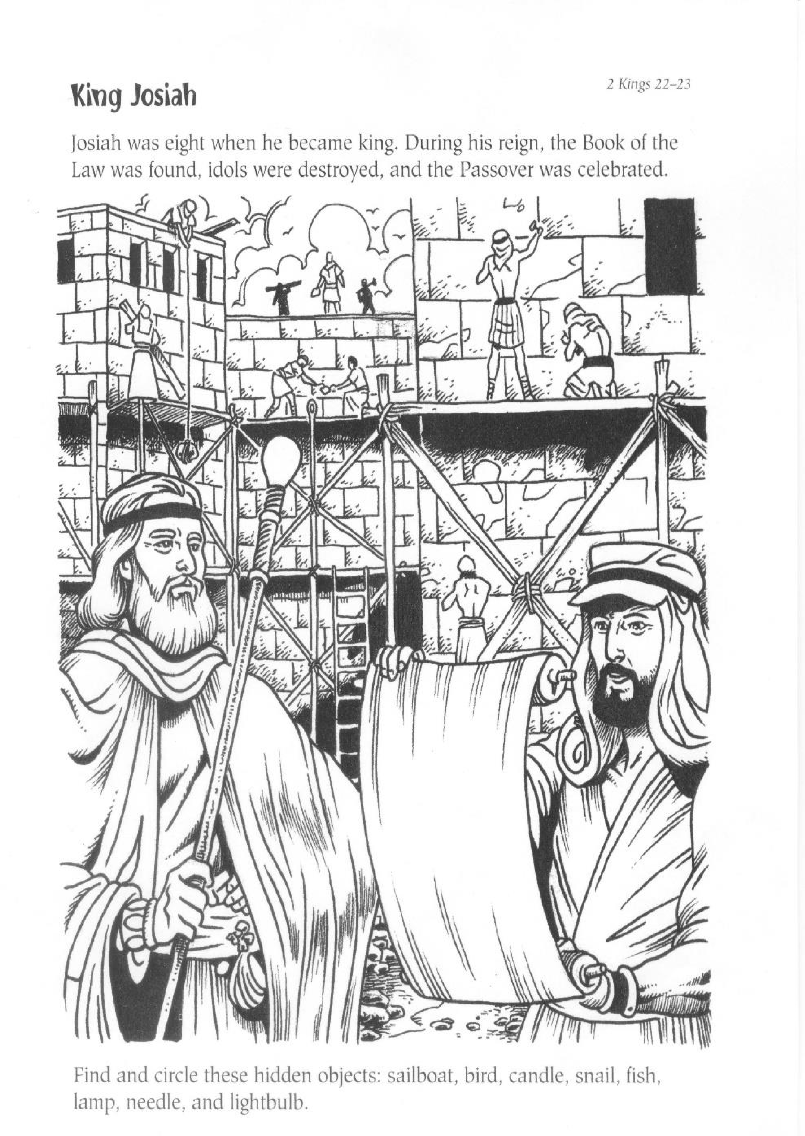

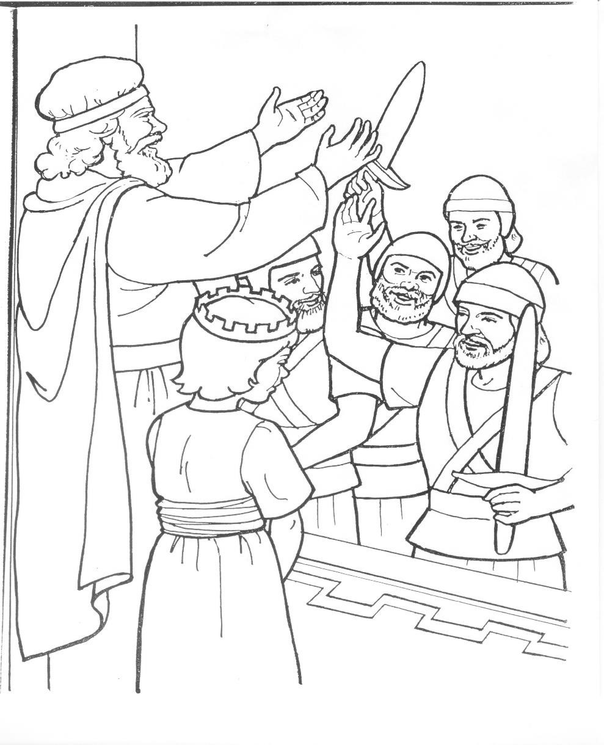

**? Answer to do you know. ● No he tore down the idols and worship the true God.**